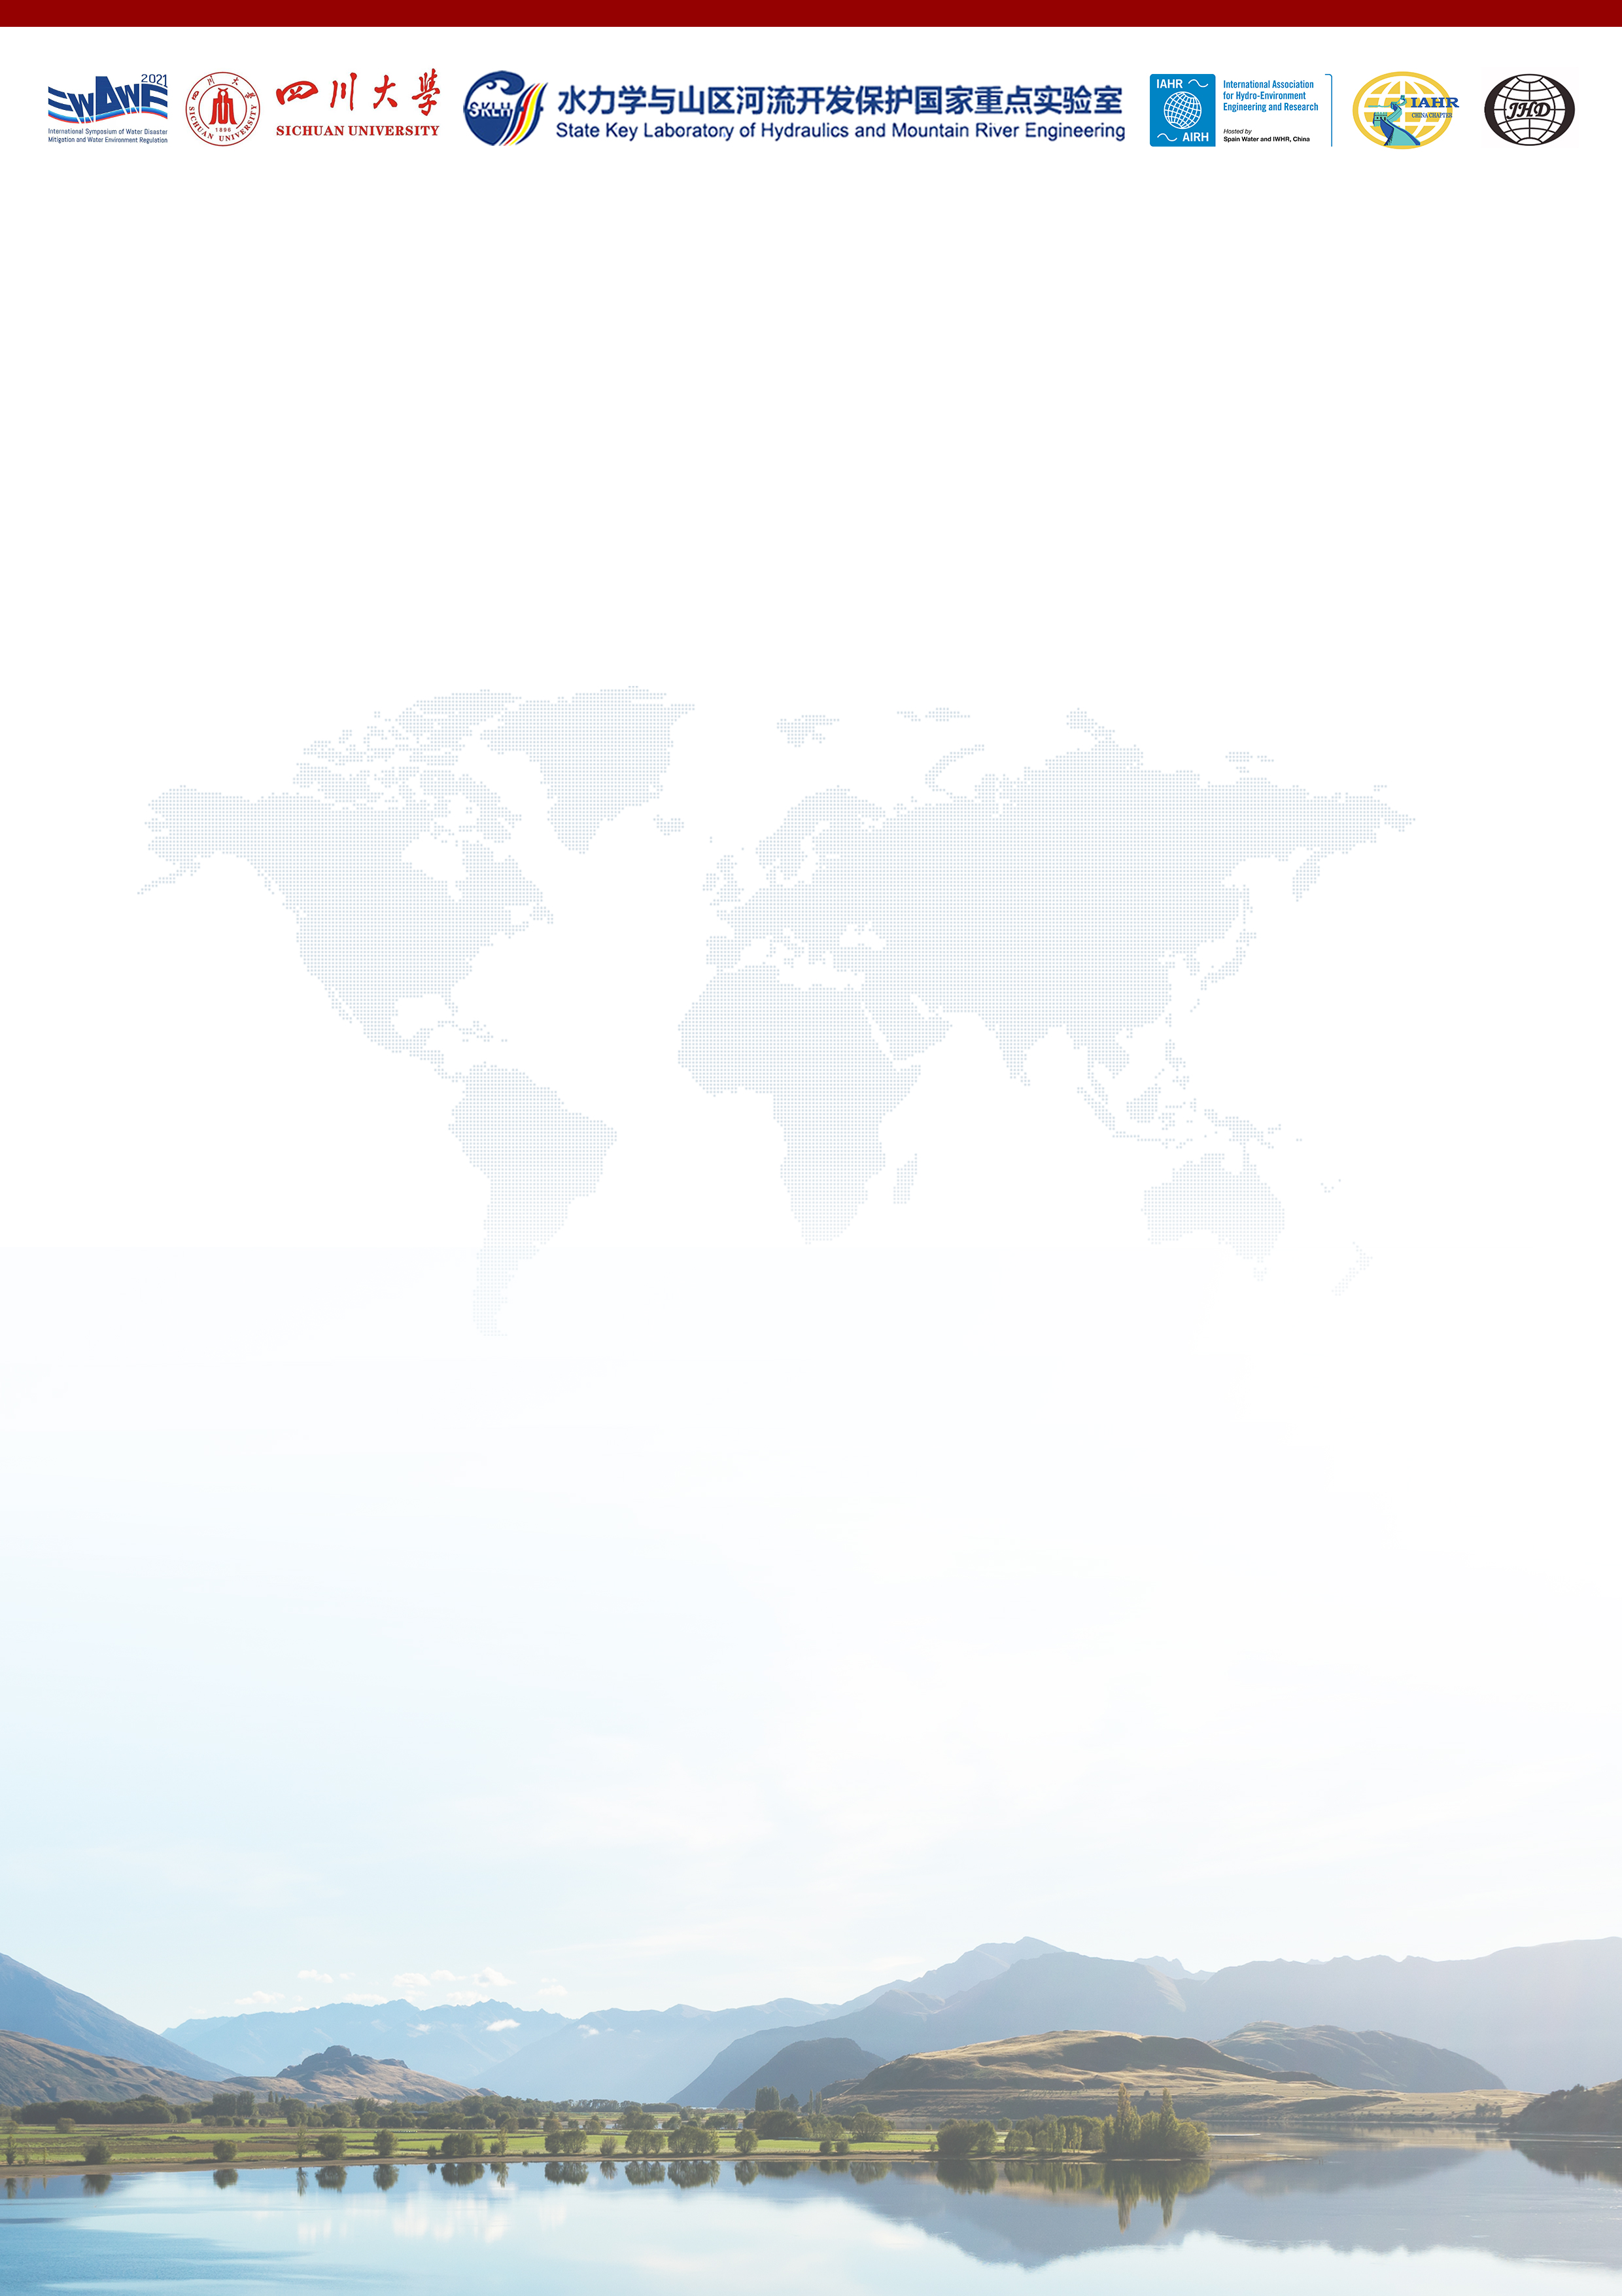
The First Announcement of
2nd International Symposium of Water Disaster Mitigation and Water Environment Regulation

Dear Colleagues,

I am delighted to announce the 2nd International Symposium of Water Disaster Mitigation and Water Environment Regulation (WDWE2021), to be held at Sichuan University, Chengdu, from July 7th to 9th, 2021.

The first symposium was successfully held by Sichuan University in 2019, to provide a platform for global academic exchanges on the scientific effort in disaster loss reduction and ecological restoration associated with the more frequent urban and rural flooding, other water disasters, and the challenging water environmental and ecological problems in the modern world. The 48 invited speeches delivered by world-leading experts from all over the world attracted over 100 young professionals, researchers and students during the two-day event.

The 2021 Symposium will be organized by the State Key Laboratory of Hydraulics and Mountain River Engineering (SKLH, Sichuan University) as a hybrid conference combining both onsite and online participation. Registration will be open to academics, professionals and students across the world. Presenters will be asked to submit their abstracts, and full paper submissions are welcomed and will be published in the proceedings of the symposium after peer-review processes. Further details of the event, including the key dates for abstract submission and registration, are enclosed below. We look forward to getting together with friends, colleagues and peer researchers/professionals and hosting every delegate with another successful symposium.

Wish you a Happy Chinese New Year,

Weilin XU, Ph.D., Professor
Chair of WDWE2021
Head of State Key Laboratory of Hydraulics and Mountain River Engineering
Vice-President of Sichuan University

February 5, 2021

1/4
Symposium Overview

Local Organizing Committee (LOC)
Chair: Weilin XU
Executive Chair: Pengzhi LIN, Jianmin ZHANG
Secretary General: Hang WANG, Ningbo CUI
Member: Wenhua ZHUANG, Qing YANG, Maolin ZHOU, Haoyue ZHENG, Wangru WEI, Ruidi BAI, Chunlin SONG, Lu WANG, Lian TANG, Min CHEN
International Scientific Committee (ISC)
James BALL University of Technology Sydney
Hubert CHANSON The University of Queensland
Xiaoqing CHEN Institute of Mountain Hazards and Environment, CAS
Sung-Uk CHOI Yonsei University
Peng CUI Institute of Mountain Hazards and Environment, CAS
Feng DAI Sichuan University
Jianhui DENG Sichuan University
Xudong FU Tsinghua University
Peter GOODWIN University of Maryland Center for Environmental Science
Shaozhong KANG China Agricultural University
Jia LI Sichuan University
Chao LIU Sichuan University
Fulai LIU University of Copenhagen
Philip Li-Fan LIU The National University of Singapore
Xingnian LIU Sichuan University
Arturo MARCANO Central University of Venezuela
Bruce MELVILLE The University of Auckland
Ioan NISTOR University of Ottawa
Hajime NAKAGAWA Kyoto University
Jianbing PENG Chang’an University
Yongming SHEN Dalian University of Technology
Huiming TANG China University of Geosciences
Silke WIEPRECHT University of Stuttgart
Lianhai WU Rothamsted Research
Pute WU Northwest A&F University
Qiang XU Chengdu University of Technology
Xingguo YANG Sichuan University

More members to be confirmed

Themes
- Water Crisis and Disaster Mitigation
- Water Pollution Prevention and Control
- Water Ecological Conservation and Restoration
- Frontiers in Water Science and Engineering

2/4
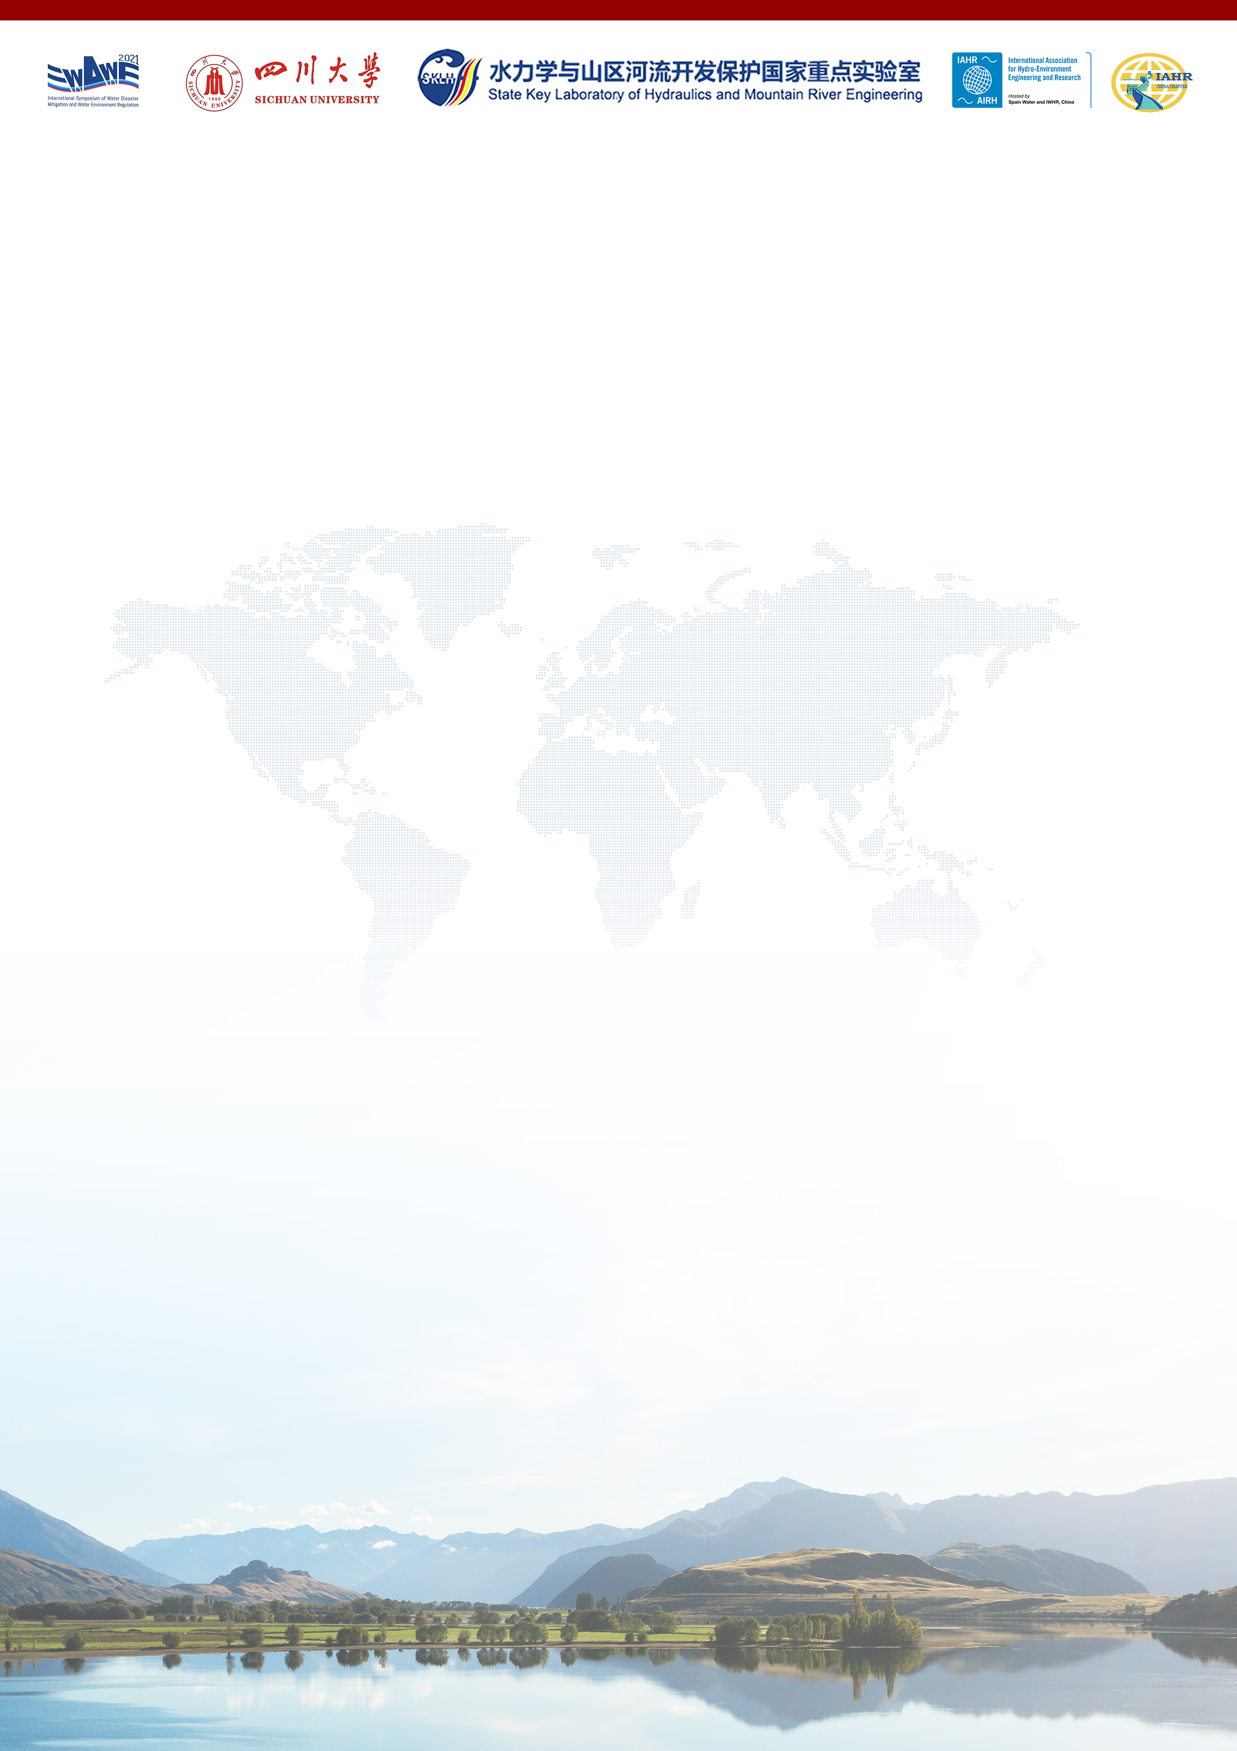
Invited Speakers
Peter GOODWIN University of Maryland Center for Environmental Science
Philip Li-Fan LIU The National University of Singapore
Hubert CHANSON The University of Queensland
Peng CUI Institute of Mountain Hazards and Environment, CAS
Jun XIA Wuhan University
Hajime NAKAGAWA Kyoto University
Shaozhong KANG China Agricultural University
Qiuwen CHEN Nanjing Hydraulic Research Institute
Pute WU Northwest A&F University
James BALL University of Technology Sydney
Ling LI Westlake University
Ioan NISTOR University of Ottawa
Qiang FU Northeast Agricultural University
Sung-Uk CHOI Yonsei University
Qiang XU Chengdu University of Technology
Hitoshi TANAKA Tohoku University
Defu LIU Hubei University of Technology
Jinhai ZHENG Hohai University
Dominic REEVE Swansea University
Junqiang XIA Wuhan University
Zongxue XU Beijing Normal University
Yakun GUO University of Bradford
Qiuhua LIANG Loughborough University
Denghua YAN China Institute of Water Resources and Hydropower Research
Xinghui XIA Beijing Normal University
Ellis PENNING Deltares
Nobuhito MORI DPRI, Kyoto University
Dawen YANG Tsinghua University
Yueping YIN China Geological Environmental Monitoring Institute
Baoshan CUI Beijing Normal University
Zaijin YOU Dalian Maritime University
Naresh SINGHAL The University of Auckland
Xiping YU Tsinghua University
Lianhai WU Rothamsted Research
Yujun YI Beijing Normal University
Asaad SHAMSELDIN The University of Auckland
Xiaohong CHEN Sun Yat-sen University
Junke GUO University of Nebraska Lincoln
Arturo MARCANO Central University of Venezuela

More invited speakers to be confirmed

3/4
Key Dates
Abstract submission deadline March 7, 2021
Notification of abstract review outcome March 14, 2021
Optional full paper submission deadline April 18, 2021
Notification of paper review outcome April 25, 2021
Receipt of final papers May 2, 2021
Online registration deadline June 30, 2021
Onsite registration deadline July 7, 2021
Conference July 7 – 9, 2021

Student Session
Technical session arrangement is to be confirmed after the abstract submission. A half-day student session will be scheduled particularly for student presenters, to help young participants better enjoy the peer discussion and communications during and after the session. Senior academics will be invited to provide comments and advices during the session upon questions. Awards for best paper and best presentation will be announced at the end of the symposium.

Proceedings
Submission of abstracts is required for oral presentations. Submission of full papers are encouraged. All submitted papers will be peer reviewed for technical content led by the Scientific Committee. The accepted papers will be included in a Symposium Proceedings published by Sichuan University Press. Selected papers will be considered for publication in peer-reviewed journals.

Host Organization
The State Key Laboratory of Hydraulics and Mountain River Engineering (Sichuan University) was founded in 1988 among the earliest established State Key Laboratories in China. The main task of the lab is to conduct scientific research, talent training and open platform construction in the field of mountain river development (especially high-dam large hydropower engineering) and protection (especially river health and water environment protection resulting from mountain river development). As a state key laboratory stationed in Southwest China with high density of world-class hydropower projects and serious mountain river issues, it plays an irreplaceable role in the research of mountain river hydraulics and high dam engineering.

Contact
Secretary Generals:
Prof. Ningbo CUI Email: cuiningbo@126.com Ph: +86-15008275024
Prof. Hang WANG Email: wanghang39@scu.edu.cn Ph: +86-13074309830
Website:
www.WDWE2021.net
WeChat official account (in Chinese): 水灾害防治与水环境调控国际会议
4/4

