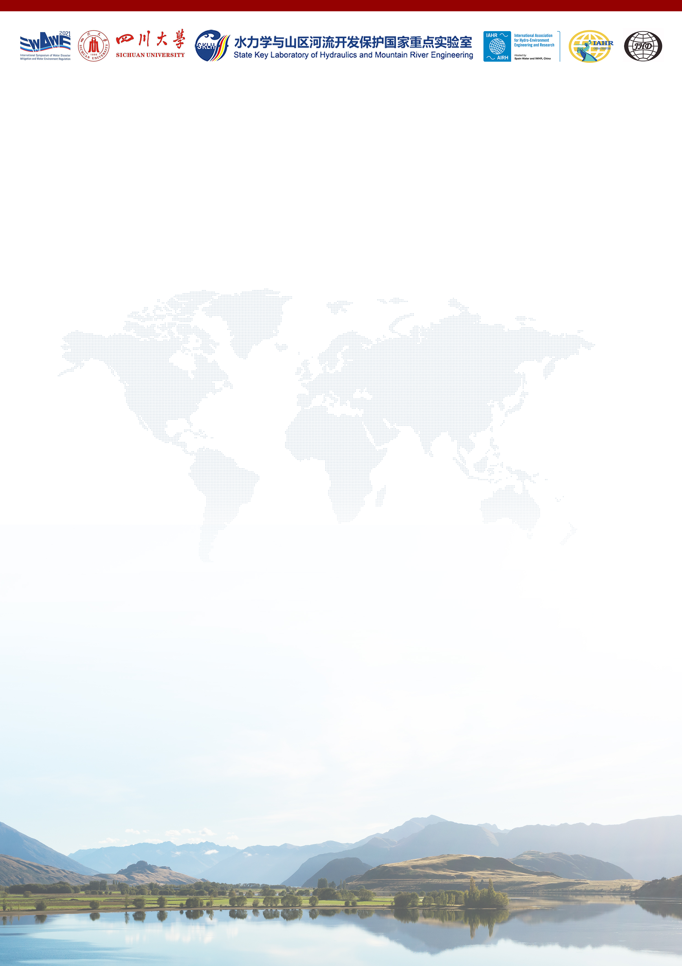
The Second Announcement of
2nd International Symposium of Water Disaster Mitigation and Water Environment Regulation

The 2nd International Symposium of Water Disaster Mitigation and Water Environment Regulation (WDWE2021) will be held at Sichuan University, Chengdu, from July 7th to 9th, 2021.

The symposium will be organized jointly by the State Key Laboratory of Hydraulics and Mountain River Engineering (SKLH, Sichuan University), International Association for Hydro-Environment Engineering and Research (IAHR) and Journal of Hydrodynamics, as a hybrid conference combining both onsite and online participation. Registration is open to academics, professionals and students across the world. Presenters will be asked to submit their abstracts via the symposium website www.WDWE2021.net before April 15, 2021, and full paper submission is welcomed and will be published in the proceedings of the symposium after peer-review processes. We look forward to getting together with friends, colleagues and peer researchers/professionals and hosting every delegate with a successful symposium.

Symposium Themes
- Water Crisis and Disaster Mitigation
- Water Pollution Prevention and Control
- Water Ecological Conservation and Restoration
- Frontiers in Water Science and Engineering

Place: Xiangyu Hotel, Chengdu, China
Date: July 7th – 9th

Key dates
Abstract submission deadline April 15, 2021
Optional full paper submission deadline May 15, 2021
Notification of paper review outcome May 30, 2021
Online registration deadline June 30, 2021
Onsite registration deadline July 7, 2021

Registration fees
Online presenters Overseas: USD 100 China: CNY 500
Online audience Free
Offline participants
Online registration (before June 30) Regular: CNY 1000 Student: CNY 500
Onsite registration (on July 7) Regular: CNY 1500 Student: CNY 750

Contact
Website: www.WDWE2021.net Email: WDWE2021@163.com
WeChat official account (in Chinese): 水灾害防治与水环境调控国际会议

Local Organizing Committee (LOC)
Chair: Weilin XU
Executive Chair: Pengzhi LIN, Jianmin ZHANG
Secretary General: Hang WANG, Ningbo CUI
Member: Wenhua ZHUANG, Qing YANG, Maolin ZHOU, Haoyue ZHENG, Wangru WEI, Ruidi BAI, Chunlin SONG, Lu WANG, Lian TANG, Min CHEN
International Scientific Committee (ISC)
James BALL University of Technology Sydney
Hubert CHANSON The University of Queensland
Xiaoqing CHEN Institute of Mountain Hazards and Environment, CAS
Sung-Uk CHOI Yonsei University
Peng CUI Institute of Mountain Hazards and Environment, CAS
Feng DAI Sichuan University
Jianhui DENG Sichuan University
Xudong FU Tsinghua University
Peter GOODWIN University of Maryland Center for Environmental Science
Shaozhong KANG China Agricultural University
Jia LI Sichuan University
Chao LIU Sichuan University
Fulai LIU University of Copenhagen
Philip Li-Fan LIU The National University of Singapore
Xingnian LIU Sichuan University
Zheng MA Journal of Hydrodynamics
Arturo MARCANO Central University of Venezuela
Bruce MELVILLE The University of Auckland
Ioan NISTOR University of Ottawa
Hajime NAKAGAWA Kyoto University
Jianbing PENG Chang’an University
Yongming SHEN Dalian University of Technology
Huiming TANG China University of Geosciences
Silke WIEPRECHT University of Stuttgart
Lianhai WU Rothamsted Research
Pute WU Northwest A&F University
Qiang XU Chengdu University of Technology
Xingguo YANG Sichuan University

Student Session
A half-day student session will be scheduled particularly for student presenters, to help young participants better enjoy the peer discussion and communication. Awards for best paper and best presentation will be announced at the end of the symposium.

Proceedings
Submission of full papers is encouraged. All submitted papers will be peer reviewed and the accepted papers will be included in a Symposium Proceedings published by Sichuan University Press. Selected papers will be further considered for publication in Journal of Hydrodynamics.

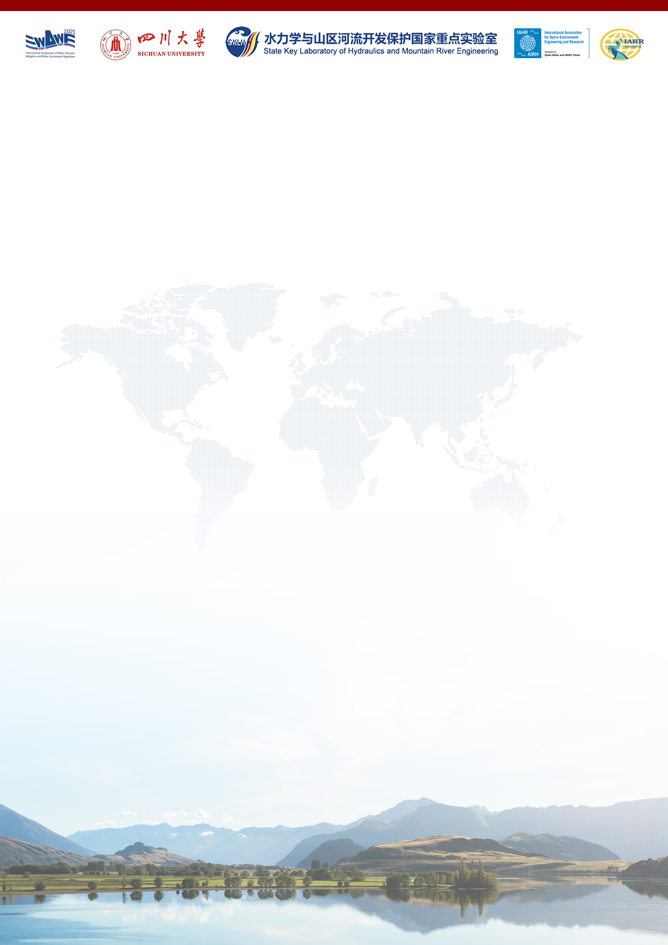
Invited Speakers
Philip Li-Fan LIU The National University of Singapore
Peter GOODWIN University of Maryland Center for Environmental Science
Peng CUI Institute of Mountain Hazards and Environment, CAS
Jun XIA Wuhan University
Shaozhong KANG China Agricultural University
Pute WU Northwest A&F University
Gretchen KALONJI Sichuan University
Hubert CHANSON The University of Queensland
Hajime NAKAGAWA Kyoto University
Qiuwen CHEN Nanjing Hydraulic Research Institute
James BALL University of Technology Sydney
Ling LI Westlake University
Ioan NISTOR University of Ottawa
Qiang FU Northeast Agricultural University
Sung-Uk CHOI Yonsei University
Qiang XU Chengdu University of Technology
Hitoshi TANAKA Tohoku University
Defu LIU Hubei University of Technology
Jinhai ZHENG Hohai University
Dominic REEVE Swansea University
Junqiang XIA Wuhan University
Zongxue XU Beijing Normal University
Yakun GUO University of Bradford
Qiuhua LIANG Loughborough University
Denghua YAN China Institute of Water Resources and Hydropower Research
Xinghui XIA Beijing Normal University
Ellis PENNING Deltares
Nobuhito MORI DPRI, Kyoto University
Dawen YANG Tsinghua University
Yueping YIN China Geological Environmental Monitoring Institute
Baoshan CUI Beijing Normal University
Zaijin YOU Dalian Maritime University
Naresh SINGHAL The University of Auckland
Xiping YU Tsinghua University
Lianhai WU Rothamsted Research
Yujun YI Beijing Normal University
Asaad SHAMSELDIN The University of Auckland
Xiaohong CHEN Sun Yat-sen University
Junke GUO University of Nebraska Lincoln
Arturo MARCANO Central University of Venezuela
David ZHU University of Alberta

More invited speakers to be confirmed

